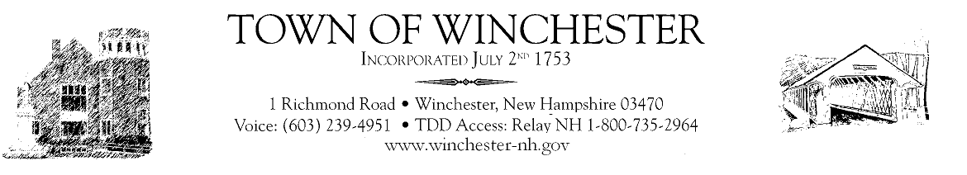

Budget Committee
Meeting
Tuesday, November 9, 2021
6:00pm
@ Town Hall

- Review Health Agencies Budgets
- Any new business that may come before the Board
- Adjourn Meeting

