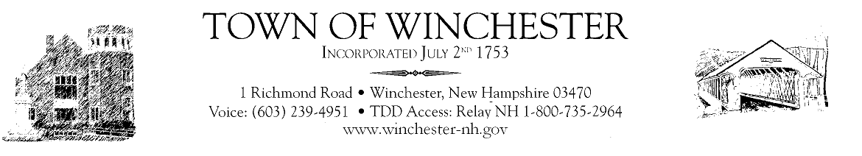
Budget Committee
Meeting
Tuesday, November 17, 2020
6:00pm
@ Town Hall

- Review of 2021-2022 Budget’s: Health Agencies

- Any new business that may come before the Board

- Adjourn Meeting

______________________________________________

Budget Committee
Meeting
Saturday, November 21, 2020
9:00am
@ Town Hall

- Review of 2021-2022 Budget’s: Cemetery, Land Use, Health, Police, Landfill, Fire, Ambulance, Welfare, Town Clerk/Tax Collector, Highway, Water/Sewer, Conant Library & Thayer Library.

- Any new business that may come before the Board

- Adjourn Meeting

