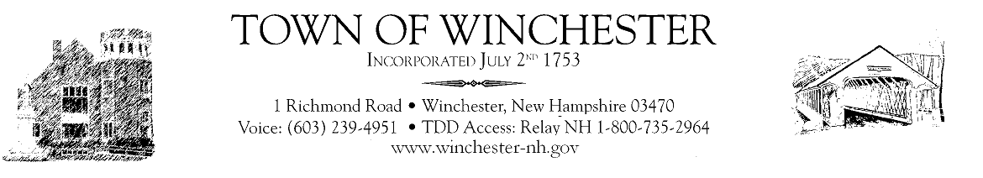

Town of Winchester
Board of Selectmen
Notice of Public Hearing

Notice is hereby given that the Town of Winchester Board of Selectmen will hold 2 public hearings on Wednesday, May 1, 2024 at 6:30pm & Wednesday, May 15, 2024 at 6:30pm in the Winchester Town Hall for the purpose of selling a strip of land approx. 19,385sf located on Plumb Pak Drive, map 6 lot 11. Questions may be addressed to the Winchester Town Hall; 1 Richmond Rd.; Winchester, NH 03470;
(603) 239-4951.

