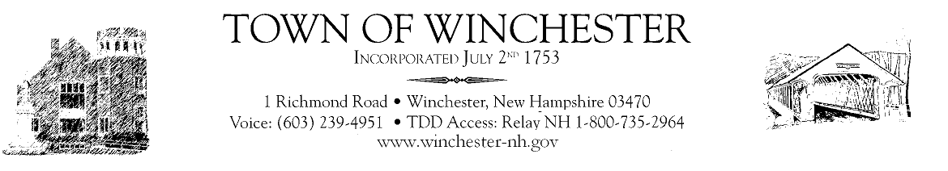

Town of Winchester
Board of Selectmen
Notice of Public Hearing

Notice is hereby given that the Town of Winchester Board of Selectmen will hold a public hearing on Wednesday, January 18, 2023, at 6:30pm in the Winchester Town Hall for the purpose of accepting and expending the DOT-Senate Bill 401 Special One Time Bridge payment in the amount of $192,235.04. Questions may be addressed to the Winchester Town Hall; Office of Selectmen, 1 Richmond Road; Winchester, NH 03470; (603) 239-4951.

