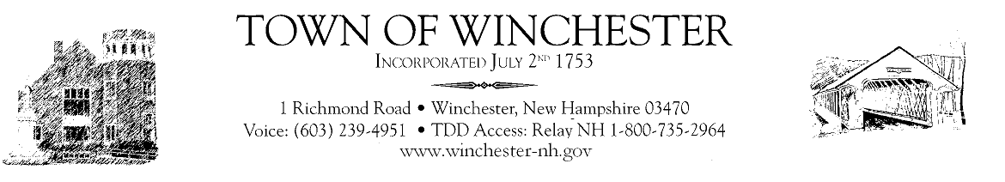

5-21-20
Dear Residents,

Things are changing slowly. We are all working to adjust to the “new normal”. As of this week Winchester has had only one confirmed case and it is believed to be self-contained. Throughout the country and here the positive cases do keep rising but the hospitalizations are down. Keep in mind the more people tested will result in more positive cases. While it appears alarming, this number is what is to be expected. This confirms what the experts have told us, the virus spreads easily and fast but 80% of the positive cases have mild or no symptoms. This doesn’t mean we let our guard down. We must continue to social distance, wash our hands, stay home when sick and wear a mask.

Isn’t it wonderful the weather is finally behaving! The more we are outside doing physical things the healthier we will be. Since the Governor has ease restrictions and I expect more to come this week, go out and enjoy a hike, or fishing, gardening, kayaking, and then stop at the ice cream shop and local restaurants for takeout or outside dining. Getting out and socializing even at a distance will lift your spirits. All businesses shall abide by the Universal Guidelines establish by the Governor’s task force. Each type of business has their own unique set of rules such. They can be found on the State of NH Economic Task Force website. The town has reached out to businesses to educate them on these new rules and to offer assistance in obtaining more information. If we all work together, Winchester will prosper once again.

If you are in need of help please reach out, there are many services in the area to help. The Catholic Food Bank is open Tuesday evenings. The Board of Selectmen have moved their Wednesday meetings back to 7pm. The Planning Board held their first meeting in two months this week. The town beach will be opening for Memorial Day weekend to limited capacity, with no large gatherings or parties and with a regular sanitizing schedule. The town hall and all departments are doing a great job serving the public. The town hall is still not open for the public to enter.

Be smart and safe this holiday weekend, remember to check on your neighbor, be kind and say thanks to all who are there helping!

