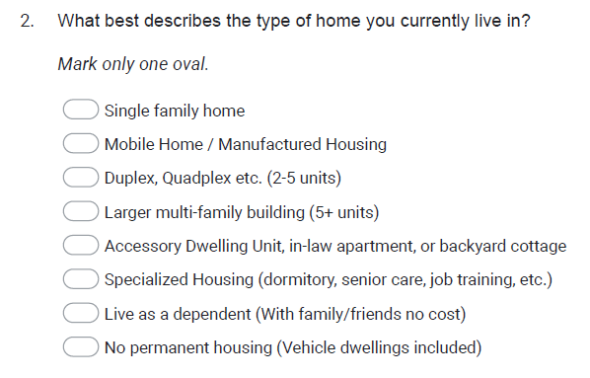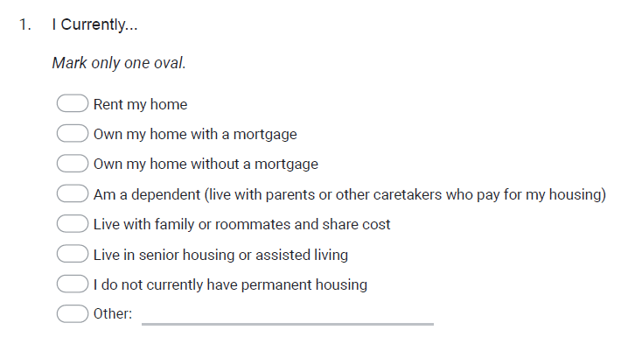**Housing Needs Survey**



