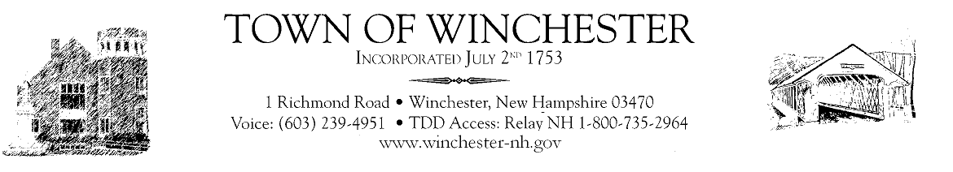
11-23-21
Dear Winchester & Ashuelot Residents,
The holidays are upon us. This year we will be able to share Thanksgiving with the ones we love and are thankful for. While some of folks are vaccinated, many are not. That means while we can gather this year, we should still take precautions. Most of us have gone on with our regular lives but do it just a little bit differently. Our advice is to consider wearing a mask and stand a little farther apart from others especially if you are not vaccinated. Outdoors is still the best safest place to gather.
More and more of us are realizing this virus is very real and is deadly. Today Covid rates are at the highest ever in the state. Many hospitals are not doing elective surgery. Hospitals are also short staffed and are at bed capacity. The positivity rate is 9.5 % with 7966 active cases in the state (15 in Winchester) and 343 hospitalized. Vaccinations are still the best way to fight the virus, keep yourself healthy and protect the ones we love. Winchester has one of the lowest rates of vaccinations in the state. Only 38.5% of residents have received their second dose. The state rate of fully vaccinated is 54.9%. Why are people not getting vaccinated? Are they afraid of it? Do they have access to get one? Do people know they are free? Do people not believe in it? Do people realize how easy it is now? Didn’t everyone get a polio, measles, and rubella vaccine when you were a child? No matter what the reason, please think about getting vaccinated. You can call your local pharmacy and get one within a couple of days.
Most of us read and listen to a variety of information from many different sources regarding the virus. This is good because this issue shouldn’t be political. It is important to digest information from various sources to make an informed decision. There are new approved medicines out there to help people sick with the virus. These medicines are approved by the FDA. These are not animal medicines or homemade remedies. If you don’t feel well, stay home, get tested and call your doctor. If we personally have not had covid, we all know someone who has. Our friends, families and neighbors have gotten sick, and some have died. The faces you see on TV and in print describing how deathly sick they were and regretting not getting vaccinated are true. This virus is here and is not a joke. Just ask someone who has had it. Vaccination is not a guarantee you won’t get covid, but it is very likely you won’t end up in the hospital on a ventilator or dead. The vaccine also helps in decreasing the number of variants.
The weather has changed, and we are now indoors more. Transmission of the virus will be easier. Plan ahead when gathering. Think who will be there, consider wearing a mask and after the initial hug, keep a little distance from grandma. The holidays are important to many of us to be with loved ones. Lets keep our loved ones safe so we can be with them next year. Remember to keep good thoughts and reach out to your neighbor. Happy Thanksgiving!

