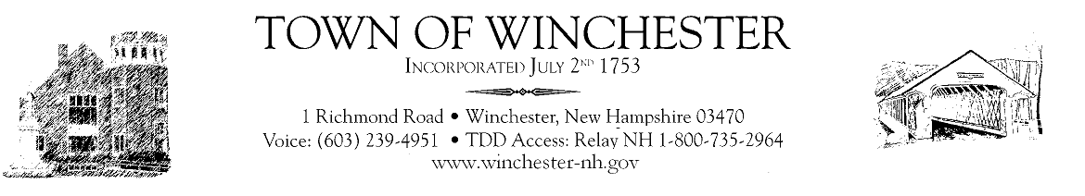

NOTICE OF REQUEST FOR STATEMENTS OF QUALIFICATIONS
FOR ENGINEERING SERVICES
OLD CHESTSERFIELD ROAD BOOSTER PUMP STATION
AND WATER MAIN REHABILITATION

The Town of Winchester is in the process of obtaining Statements of Qualifications from qualified engineering firms detailing the firms’ qualifications, project approach, technical expertise, management and staffing capabilities, references, and related prior experience. Required professional services will include but are not limited to preliminary engineering services, design- and construction-related services, preparation of bidding and contract documents, participation in the evaluation of bids received, and monitoring and observation of construction activities to ensure compliance with plans and specifications associated with Old Chesterfield Road Booster Pump Station and Water Main Rehabilitation. The scope of the work includes preparation and submittal of National Environmental Policy Act (NEPA) Environmental Review, preparation of the Application Form for Federal Assistance (SF424), required forms and work plan in accordance with 2 CFR 200, the design of a package booster pump station to increase pressures in the Old Chesterfield Road area and approximately 8,800 linear feet of new water main and appurtenances on Old Chesterfield Road, Howard Street and Clark Road, bidding services, construction administration and post construction services. All design work shall be completed by July 2024.
Procurement of said services will be in accordance with elements of the procurement process in 40 U.S.C. § 1101-1104. Minimum requirements for proposers include proof of listing on NH DES Roster of Prequalified Consulting Engineers in Category 4 and meeting the Town’s insurance requirements. Insurance requirements are the following:
Type of Insurance | Minimum Limits Required
Workers Compensation:  Employers Liability: | Statutory  $1,000,000 each accident  $1,000,000 each employee – disease  $1,000,000 disease aggregate
Commercial General Liability: | $1,000,000 each occurrence combined single limit  $2,000,000 general aggregate, each project for premises/operations  $2,000,000 products/completed operations aggregate
Business Automobile Liability Insurance: | $1,000,000 each accident combined single limit
Pollution Liability Insurance: | $5,000,000 each occurrence and aggregate
Umbrella or Excess Liability: | $5,000,000 each occurrence and aggregate

Qualified firms/candidates interested in being considered for this project must submit Statements of Qualifications containing each of: (1) letter of interest; (2) project approach and scope of services; (3) statement of qualifications and experience of staff persons who will be involved with the project; (4) at least three references; (5) related prior experience with infrastructure projects, federally funded projects and with the Town of Winchester. Submit the requested information to the Karey Miner, Town Administrator for Town of Winchester located at 1 Richmond Road, Winchester, NH 03470 or kminer@winchester.nh.gov; no later than 4:00pm on January 10, 2024, in order to receive consideration.
Attention is directed to the fact that the proposed project(s) may be undertaken with a variety of Federal and state funds and that all work will be performed in accordance with the regulations issued by such agencies and the State of New Hampshire pertaining thereto.

The Town of Winchester shall evaluate the statements of qualifications and performance data and other material submitted by interested firms and select a firm which is best qualified to perform the desired services. The Town of Winchester shall rank, in order of preference, the professional firms deemed to be the most highly qualified to provide the services required and shall commence scope of services and price negotiations with the highest qualified professional firm for engineering services. An interview may be conducted with the firm, if necessary, which may include discussions regarding anticipated concepts and proposed methods of approach.
All proposals submitted in response to this RFQ shall become the property of the Town of Winchester. All reports, documents, maps and materials developed by the engineer shall be the property of the Town of Winchester and shall be treated by the Town as public information.
All unsuccessful respondents will be notified. The Town reserves the right to reject any or all proposals or waive informalities in any proposal. The Town of Winchester reserves the right to terminate any contract entered into as a result of this RFQ at any time, provided that written notice has been given to the firm at least thirty (30) days prior to such proposed termination date.

