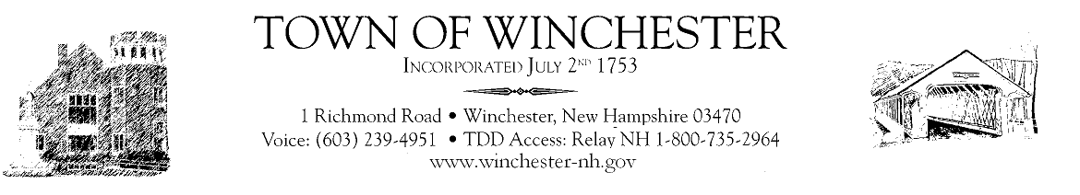

5-8-20
Dear Residents,

Hope all is well and that you are out enjoying the nice weather. There have been many changes in the last week. There is both good and bad news. The good news is the Governor has relaxed some business closures. Golf courses, retail establishments, manufacturing, restaurants, campgrounds, drive-ins, barbers/salons, hospitals, and parks now can reopen on different dates this month BUT with very clear requirements and restrictions. All businesses shall abide by the Universal Guidelines establish by the Governor’s task force. Each type of business has their own unique set of rules such as; retail can only have 50% occupancy, campgrounds are limited to NH residents and to those who have memberships (seasonal), and restaurants can now offer outside dining with 6ft between tables. All of the information and guidance on COVID-19 can be found on the State of NH website- www.nh.gov

The bad news is the number of cases continues to increase in the country and state. Deaths is NH are sadly primarily the elderly. That does not mean we let our guard down. We ALL must continue social distancing, hand washing and mask wearing. This will be our new normal for quite a while. We need to stay home when we can, go out smartly, and do our best to be safe and courteous all while supporting our economy. If you are in need please reach out, there are many services there to help.

The Board of Selectmen have moved their Wednesday meetings back to 7pm. The town beach plans on opening for Memorial Day to limited capacity, with no large gatherings or parties and with a regular sanitizing schedule. The town hall and all departments are doing a great job serving the public. The Town Hall is still not open for the public to enter but are available by phone or email.

Remember to check on your neighbor, be kind and say thanks to all on the front lines.

