Work to do in 2022
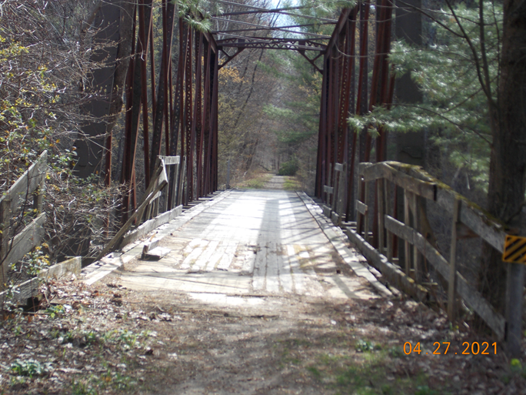
South Bridge work – deck and railings
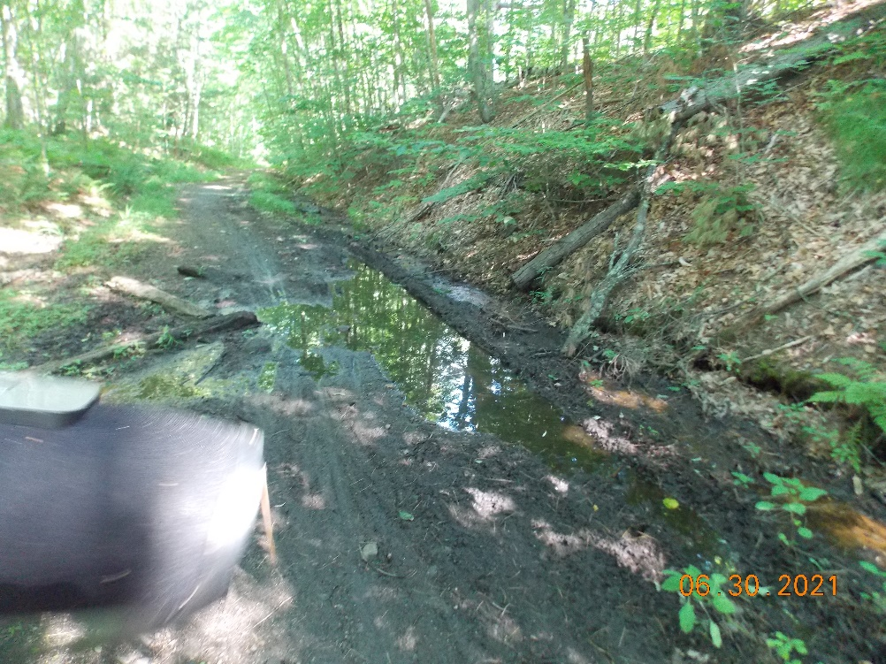
Off Back Ashuelot Road drainage

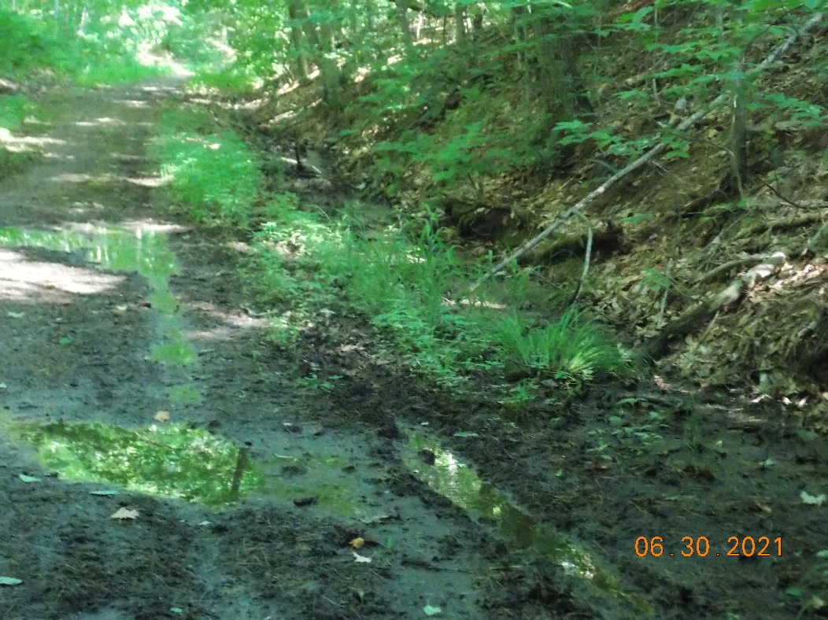
Off Back Ashuelot Road drainage

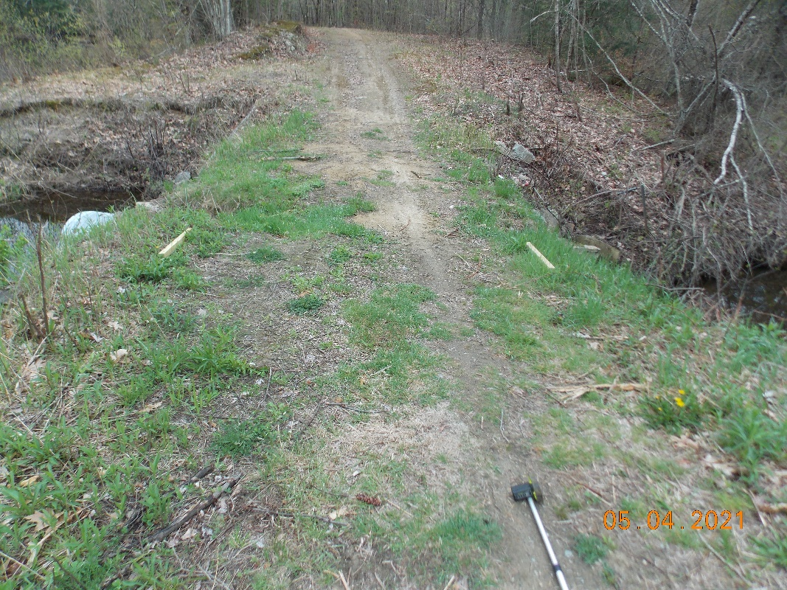
Trail stability, widening and surface improvements off Old Westport Rd.

